Optimizing RFID Portal Locations in Distribution using Systematic Layout Planning (SLP)
ERICK C. JONES, CHRISTOPHER A. CHUNG, and XIAOFEI GAO
1. Department of Industrial Management System Engineering, University of Nebraska-Lincoln, NH 175, Lincoln, NE, 68588

Radio Frequency Identification (RFID) has become important to distribution and logistics operations due to current mandates by Wal-Mart and the Department of Defense. In order to meet these mandates, distribution operations have to re-layout their distribution facilities to accommodate these RFID systems. This transcript describes a layout algorithm that supports optimizing the design of RFID system and allocation of space for this optimized system by improving facility design. The methodology described includes integrating multi-objective architectural approach involving data environment analysis, RFID interrogation zone optimization, and evaluating layout improvement alternatives using BLOCPLAN software that uses a computer aided algorithm approach.

- Introduction (Warehouse layout algorithm and RFID features in distribution process)
The manufacturing facility layout design (FLD) has been discussed by a number of researchers. Continuous improvement has been achieved through the use of simulation and computer aided programs for designing facilities in actual manufacturing and warehouse environments. However, Facility Layout Design (FLD) still is a complex and broad area that cuts across several specialized disciplines. Basically, the facility layout problem is to determine the “most efficient” arrangement of cells or functional departments subject to flow and capital constraints imposed by the original layout, management, and the site requirements.
The optimum solution for these facility layout problems is not only controlled by numerical function, but more depends on the accepted baseline of the application of site and relevant requirements. Therefore, the solution for each single layout problem should not be single solution with the optimum result based on the ratio of each function department and its weight value. Most of the research on facility layout utilizes the classical concept about classification of layout problem by either the Quadratic Assignment Problem (QAP) or a large-scale mixed integer programming problem (Montreuil 1990). Whereas nonlinear programming (NLP) formulations have been solved by numerical methods (Tam and Li, 1991; van Camp et al., 1992), by simulated annealing (Tam, 1992) or by genetic algorithm approaches (Tate and Smith, 1995). Mix-integer programming (MIP) formulations have been solved by ad hoc interactive designer reasoning (Montreuil and Ratliff, 1989) or by reducing the MIP to a linear programming optimization problem either by qualitative reasoning (Banerjee et al., 1992) or, once again, by ad hoc interactive designer reasoning (Montreuil et al., 1993), and by genetic approach (Banerjee and Zhou, 1995). Although integer and non-integer problems have solved complicated layout problems which are 2-Dimensional with flow and capital consideration, particular situations and single case problems may have to be evaluated in other ways.
RFID facility layouts with warehouse applications introduces a new type of parameter to the traditional FLD problem. The following sections illustrate the differences.

SLP Muther (1979) developed a layout procedure known as Systematic Layout Planning (SLP). It uses as its foundation the activity relationship chart which described in the facility layout process. SLP is based on input data and an understanding of the roles and relationships between activities, a material flow analysis (from-to-chart) and an activity relationship analysis (activity relationship chart). This analysis results in a relationship diagram. The next two steps involve the determination of the amount of space to be assigned to each activity. Based on modifying considerations and practical limitations, a number of layout alternatives are developed and evaluated. The SLP procedure can be used sequentially to develop first a block layout and then a detailed layout for each planning department. The following example discusses the application of SLP with an RFID warehouse design procedure.
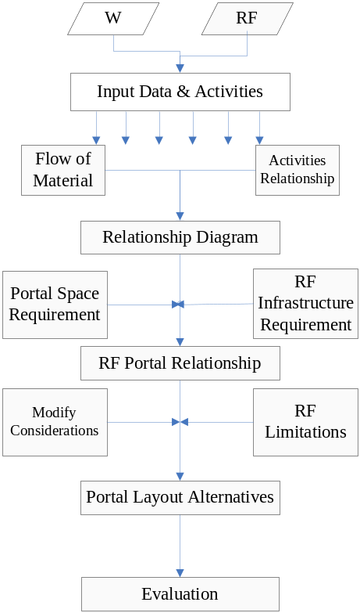W: warehouse
Figure 1: SLP Procedure R: RFID

- Modeling Procedure
Phase 1: multi-objective RF Warehouse architecture
The overall RFID Warehouse Implementing System includes 3 main parts, RFID edge layer, RFID physical layer and enterprise integration network. The RFID physical layer is the connection of other two layers. The RFID system is designed to process streams of tag or sensor data coming from one or more readers. The edge layer has the capability to filter and aggregate data prior to sending it to a requesting application. For
example, an action (tag read) is triggered when the object moves or a new object comes into the reader’s view. The RFID edge servers filter and collect the tag data at each individual site and send it over the internet to the third layer-enterprise integration layer. The localized data is identified by moving actions and stationary actions separately which divide the RFID reading type to Portal door distribution process within limited range and mobile reader inventory checking. The fundamental tenet of warehouse portal distribution system is that they must be able to accommodate changes that may occur on a network. The portal devices provide real-time, positioning access capabilities to user communities, delivering and searching personal data. It allows external customer and partner accessing with data protecting and securely access.
We can now divide the RFID warehouse system into three parts as we discussed before, the physical layer, the logic layer and the system integration layer. Each layer has different components depending on what functions the RFID system needs. By understanding the flow in the warehouse we can determine the types of tag and antennas needed in the warehouse.

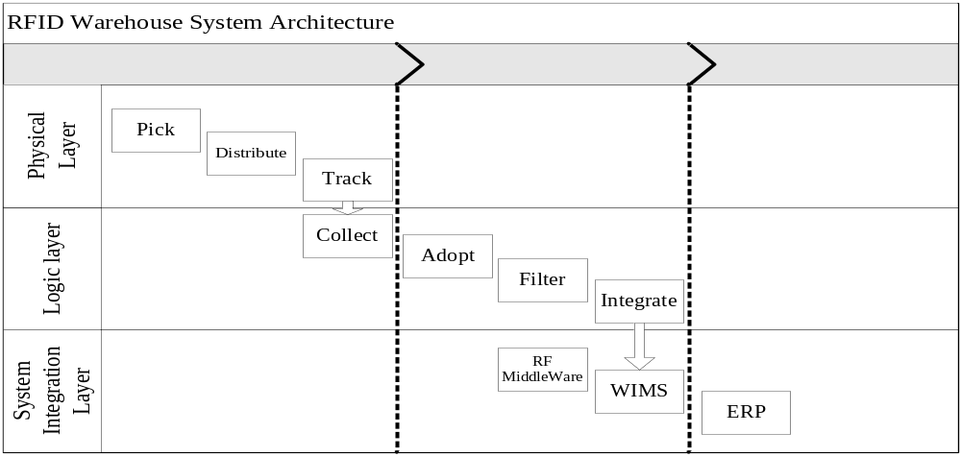
Figure.3.1 RFID operation in distribution process

Basically, the RFID implementation in any process has two to three layers. The physical layer produces log events for RF sensor during process executions. Logic layer records the log events related data including filter and integrate functions. The analysis of the physical layer activity has been discussed in facility layout research. The difference between previous research with RFID facility layout is that the data flow should be added as a factor that influences the RFID warehouse efficiency and performance.
First, the production process was its own upstream and downstream flow. Each department and activity function has multiple interactions with the others which layout are defined by traditional facility layout algorithm. For any given department, the overall work flow for sites and how and where the functional part fits into it. But for RFID warehouse, the labeling function part is substituted by two dimension portal door with installed antenna.
Phase 2: data environment analysis
The data flow through the distribution process in warehouse is one of the design components of RFID warehouse layout. The goal of such activity is to define the input and output data in order to confirm the efficiency of data flow and its physical flow. Data standards standardize data formats and data organization to ensure that the required data can be smoothly exchanged within the supply chain. The work flow and data flow are both generated by production flow from physical layer to logical layer. All the data through picking to distributing process are generated by RFID equipment including the tags on each pallet or antenna on the portal. Therefore, the location of RFID equipment has influential power on accuracy of distribution process which will form the individual data flow according to the work flow. The location of RFID antenna, we call it sensor in this paper will be discussed in this paper. First, the ‘sensor’ is used to refer to a device which is connected, via network or RF communication medium, to other sensor devices in the network. The location of sensors in the warehouse relate to either its environment or data traffic flow itself which detected by fixed antenna on portal door. Similarly, the data flow will be employed by sensors specifically in the picking entrance portal and distributing portal. Therefore, the data traffic through two portal doors and its layout will be our considered in this paper. The other communication between the nodes in warehouse we will discuss in the future work. In order to measure the accuracy and efficiency of RFID performance in warehouse, we are using ratio to evaluate the relationship of performance and efficiency of RFID readability which is which equals to the simple relationship between input and output data which will be related to regression analysis to show fair performance.
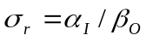 (1)
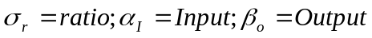
However, this ratio only gives an average performance for RFID readability. The components of Input require the precise data to evaluate the environment and performance. But we measure the benchmark of the performance used to compare the different input data and data flow. For example, the different amounts of workflow reflect the different data flow in warehouse, but the benchmark gives us a reliable data to measure different warehouse environment and work flow.
The statistical power analysis estimates the power of the workflow to detect a meaningful effect, given product flow size, significance level, and standardized effect size. Product flow size analysis determines the product flow size required to get a significant result, given statistical power, test size, and standardized effect size. These analyses examine the sensitivity of statistical power and product flow size to other components, enabling researchers to efficiently use the research resources. According to the power of the data analysis, we know the work flow during distribution process can be too low or too high, which will influence the capital loss for warehouse. If sample size is too large, time and resources will be wasted, often for minimal gain. For the benchmark as we discussed before, we used GPOWER, high-precision power analysis software, to determine the product flow size we needed so that we can draw a powerful conclusion. The inputs of GPOWER for determining the flow size in linear multiple regression model are effect size, the alpha level, power value and the number of predictors. GPOWER uses f as a measure of effect size, which has relationship with R (coefficient of determination: the total proportion of the dependent variable variability that is explained by predicted variables) as the below equation described:
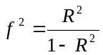 (2)
In this experiment, we used f=1.5 (R=0.6), We used alpha value (0.05), power value (0.90) and the number of predictors (4) as other three inputs.
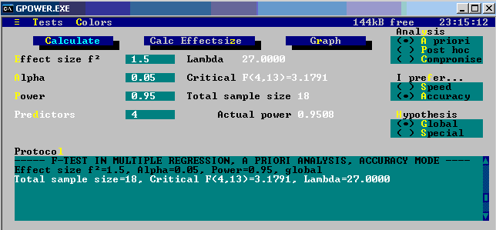
Figure3.2 Results screen from GPOWER program
Phase 3: portal interrogation network algorithm
Special considerations should be addressed when setting up an RFID system with multiple interrogators that have overlapping interrogation zones. For instance, a pair of reader in portal door interrogation zone may interrogate multiple tags in a dynamic environment.

The concept of interrogation will be abstracted as ‘read zone’ as for the practical and real environment reason in the following content. By considering the warehouse environment requirement for RFID application in distribution process, the portal door RF read zone will be limited in some ranges between dock equipment and RF interrogation range. The ranges of RF antenna (portal) and physical range of dock door layout can be described as n – vertex graph which G (V = {1,…,n}, E), and for each edge 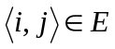 - its Euclidean “length” 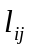. Denote a 2D layout of the graph by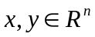, where the coordinates of vertexare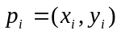. Denote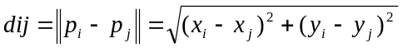. In the non-noisy version of the problem, we know that there exists a layout of the antennas that realizes the given edge lengths (i.e.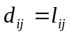). Our goal is then to reproduce this layout. Fortunately, there is additional information which we may exploit to eliminate spurious solutions to the layout problem – we know that the graph is a complete description of the close antennas. Consequently, the distance between each two nonadjacent antennas should be greater than some constant r, which is larger than the longest edge. This can further constrain the search space and eliminate most undesired solutions. Formally, we may pose our problem as follows:
Layout problem given a graph G (V = {1,…,n}, E), and for each edge - its Euclidean “length” , find an optimal layout (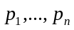) (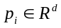is the location of the antenna i), which satisfies for all 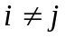:
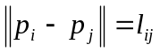 if (3)
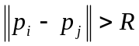 if 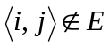 (4)
Where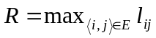. An optimal layout is similar to that generated by common force-directed graph drawing algorithms that place adjacent nodes closely while separating nonadjacent nodes. Therefore, we may estimate the distances between nonadjacent antennas and then give constructive suggestions to minimize the blind spot within the reachable zone.

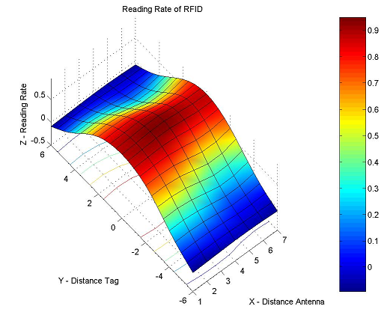
Figure3.3.3-Dimension RF interrogation zone (effective range)

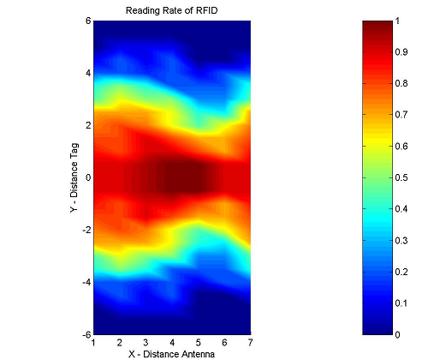
Figure3.4.2-dimension RF interrogation zone (effective range)

From the graph in Figure 3.3 and Figure 3.5, the interrogation zone from a pair of antenna gives us a visual description for the range we calculated in formula 3 and 4. The center red zone means the high readability zone for 2 inch from each side of portal door. The accuracy deduced with the increasing of the distance from tag to each side of the portal. Estimating an antenna’s physical coordinates according to the feature and requirement of RFID and warehouse system. The data that antenna is reported, should be accompanied with an indication of where in space that data was reported. The bandwidth and limitations of antenna network made it necessary for the data location coordinates of physical location of portal door in warehouse. In many cases, location itself gives the range of data that should be sensed – localization drives the need for RFID antennas network in warehouse and distribution process, which is able to locate the items and tagged parts. In addition, the accuracy of geographic routing and graph algorithms bring the next step to validate the portal and other function parts in warehouse.

Minimum maneuvering distance between the back of the dock leveler and the beginning of the staging area & Recommended dock staging dimensions (Thompkins, 1982)
Equipment Used | Distance (ft) | Item | Dimension (ft)
None (manual) | 5 | Served road width
Hand truck  Two wheel  Four wheel  Hand lift (jack)  Narrow aisle truck  Lift truck  Tow tractor | 6  8  8  10  12  14 | One-way traffic  Two-way  Gate openings, Vehicles only  One-way traffic  Two-way  Gate openings, vehicles + pedestrians  One-way  Two-way | 12  24  16  28  22  34
Table3.1 Sources from Copyright Institute of Industrial Engineers

The design of portal door and the layout of RFID antennas combined both frequency interrogation and physical portal length so that the tagged pallets will be tracked and the employed frequency from antenna can record the data with moving tags.

- Layout Improvement Alternatives and numerical results
Relying on the basis of implementation and RF facility layout principle, the facility layout algorithm will follow the baseline model we discussed above. Therefore, the qualitative algorithm is deployed to analyze the overall function parts. The layout algorithm continues to develop the relationship between each function parts including warehouse layout and RFID distributing zone. Because the limitation of the RFID interrogation zone, we consider the correlated to the RF facility layout.

  - Computer-aided program algorithm approach (BLOCPLAN)
The program generates and evaluates block type layouts in response to user supplied data. It is used for single story layouts. BLOCPLAN uses a "banding" procedure to develop layouts. This permits a large range of possible layouts for a problem. For a nine department problem, the number of possible layouts is close to 20 million, and for a 15 department layout there are more than 2.6 X 1013 possibilities. Each department will also be rectangular in shape. The structure that holds the departments will also be rectangular in shape, and the user may select the length/width ratio of the structure.

  - Relationship data
BLOCPLAN uses the relationship codes described by Muther in "Systematic Layout Planning", (Muther 1973, CBI Publishing, Boston, Mass). The each sub-procedure we discussed in SLP flowchart shows that the functional departments are defined by the material flow. We take one of the typical warehouses as an example, for BLOCPLAN, they use adjacencies for one type of layout analysis. We define the departments as, picking/receiving, storing, inspecting, forward picking, sorting, shipping, and dock to dock. The differences between classic warehouse layout algorithm using BLOCPLAN and RFID applied warehouse is, the consideration of adjacent function zone are separated for the reason of interfaces between sensors. For instance, the picking, forward picking, shipping and dock to dock zone are considerably separated according to the amount of product flow.

For this example, Table 4.1 illustrates the departments and the square footage required for the each department.

Figure 4.1 illustrates one possible solution to the given problem. This solution has a layout score of 0.72. Layout scores may range from 0 to 1.00. Higher scores indicate greater satisfaction of the adjacency relationships specified in the problem parameters.

Table 4.2 proves additional analysis results for the solution provided in Figure 4.1. This table provides the X and Y centroid of each department along with the department’s length, width, and its length/width ratio.

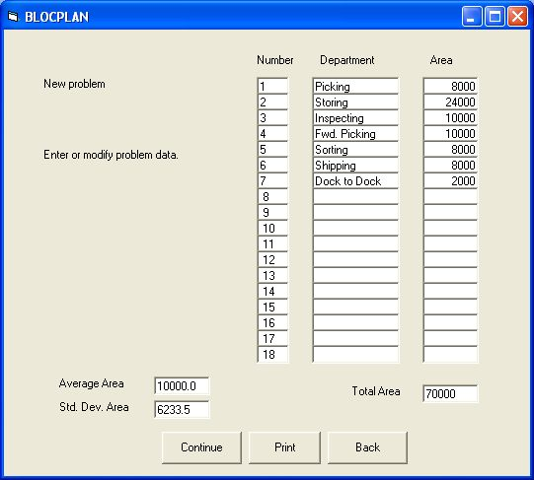

Table 4.1 Layout Data

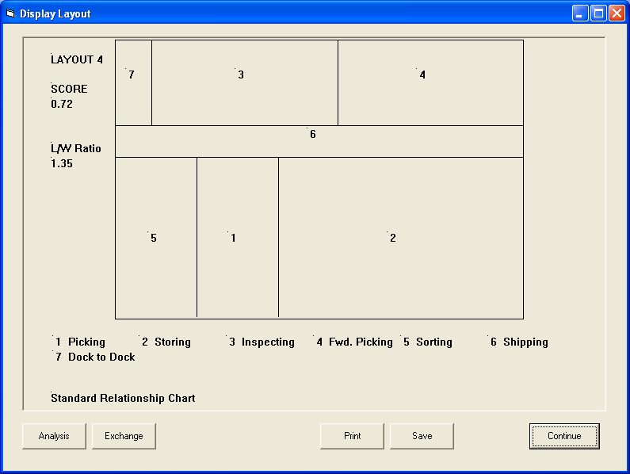

Figure 4.1 Layout

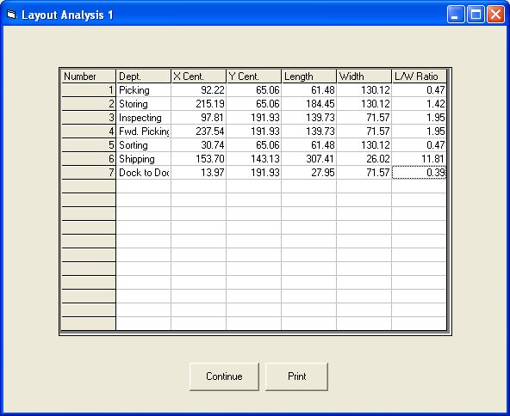

Table 4.2 Layout Analysis

- Discussion and Conclusion

The use of Radio Frequency Identification (RFID) systems in both existing and new facilities requires rethinking traditional layout approaches. This is necessitated by the need to take into consideration the department relationship requirements added by RFID system components. What may have previously been an optimal facility layout, may no longer be optimal.

This paper describes a layout methodology that takes an integrating multi-objective architectural approach involving data environment analysis, and RFID interrogation zone optimization. The effectiveness of the resulting layouts can be evaluated using facility layout software such as BLOCPLAN for Windows.

- References

